DATE: **March 22nd, 2021**

TO: **Dr. Deirdre Hunter**

FROM: **Sindhuja Darisipudi, Nora Han, Joseph Urso, Michael Tang, Jason Ye[1]**

**Team Moonrats (**[**5moonrats@gmail.com**](mailto:5moonrats@gmail.com)**)**

SUBJECT: **Water Assessment Incubator Gantt Chart Creation**

**Gantt Chart Creation Process Introduction**

Our team will build a portable incubator that enables E. coli to be grown on Petrifilms. To accomplish this, we will design an incubator using a cylindrical thermos as the main container and insulation method. This design solution contains the following core components

1. A rectangular shell that fits inside the thermos to hold the Petrifilms in place.
2. A control system for controlling temperature that involves using a temperature sensor, heating tape, battery, and microcontroller.
3. A redesigned thermos lid that is able to separate the heating system for the Petrifilms from the necessary electrical components for the control system.

We obtained these three components by reorganizing our design blocks. We chose to subdivide our design solution using a reorganization rather than a work breakdown structure after we realized that each design block could be easily sorted into a discrete prototype component. The original design blocks were data logging/display, heating, insulation, power source, and shape. The shape and insulation design blocks were sorted into component 1, which deals with how the Petrifilms are stored and kept warm. We then combined data logging/display, heating, and power into component 2, the control system. After having sorted all design blocks into components 1 and 2, the final task was to determine the arrangement of these two components within the thermos, which is what component 3 is concerned with.

We also subdivided our tasks that were not related to prototyping. For instance, we subdivided the oral presentation into the three tasks of dividing responsibilities, creating the slide deck, and rehearsing. We also subdivided each client interview into preparing questions before the interview, and executing the changes discussed afterwards.

For the low fidelity prototype, we decided to solely focus on the physical layout of our thermos. For component 1, this meant designing how this rectangular shell for holding the Petrifilms would look and attach to the thermos. For component 3, this meant designing a lid that could fit and separate the battery and microcontroller from the heating tape.

For the medium and high fidelity prototypes, we split the design aspects into the same 3 components as above. However, for these prototypes, we will be more focused on the actual implementation of these tasks, rather than simply designing the arrangement of components.

After subdividing our design solution into these three main tasks, we then began to decide on the time frame for prototyping these components. In particular, we allocated roughly the same amount of time to all three components. This was because, from prior experience, we deemed all three tasks to be equally time consuming: the control system will be difficult because, as many in our group discovered from taking COMP 140, coding is time-consuming. On the other hand, creating the mesh and redesigning the lid will be time consuming because they require both CAD as well as 3D printing. Creating the CAD model for our first technical presentation took roughly a week, and so we made sure to allocate over double that time to account for time lags in printing.

We divided leadership of these tasks into what each person had the most experience with. Component 1 will be led by Jason, as his experience in mechanical design is critical for designing the mesh. Component 2 will be led by Michael and Sindhuja, who both have experience in electrical design and coding. Finally, redesigning the lid to insulate the electrical components from the heating element will be led by Joseph and Nora, who both have experience in thermodynamics.

**Gantt Chart**

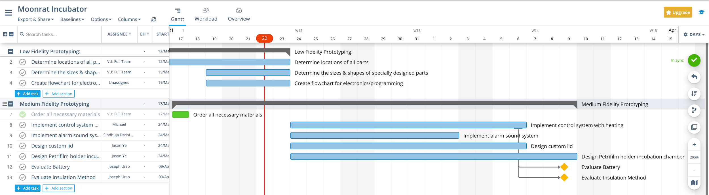

***Figure 1: Part 1 of Moonrats Gantt Chart***

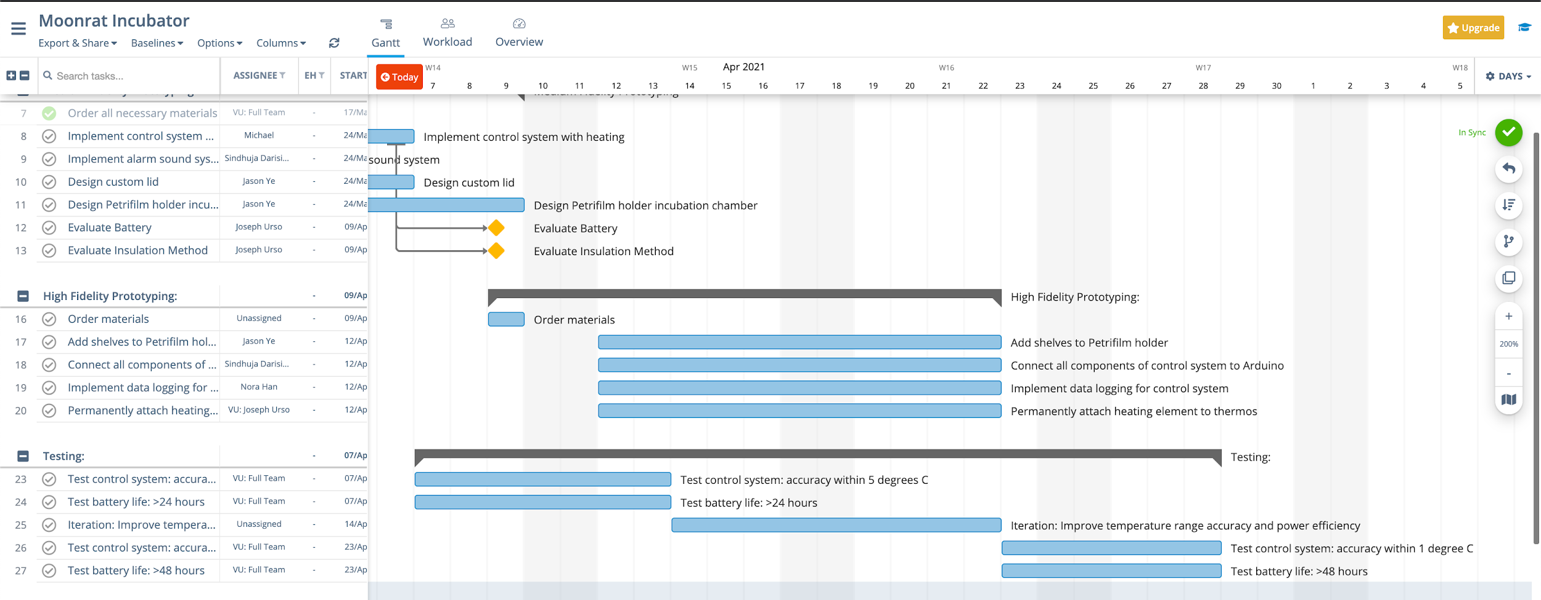

***Figure 2: Part 2 of Moonrats Gantt Chart***

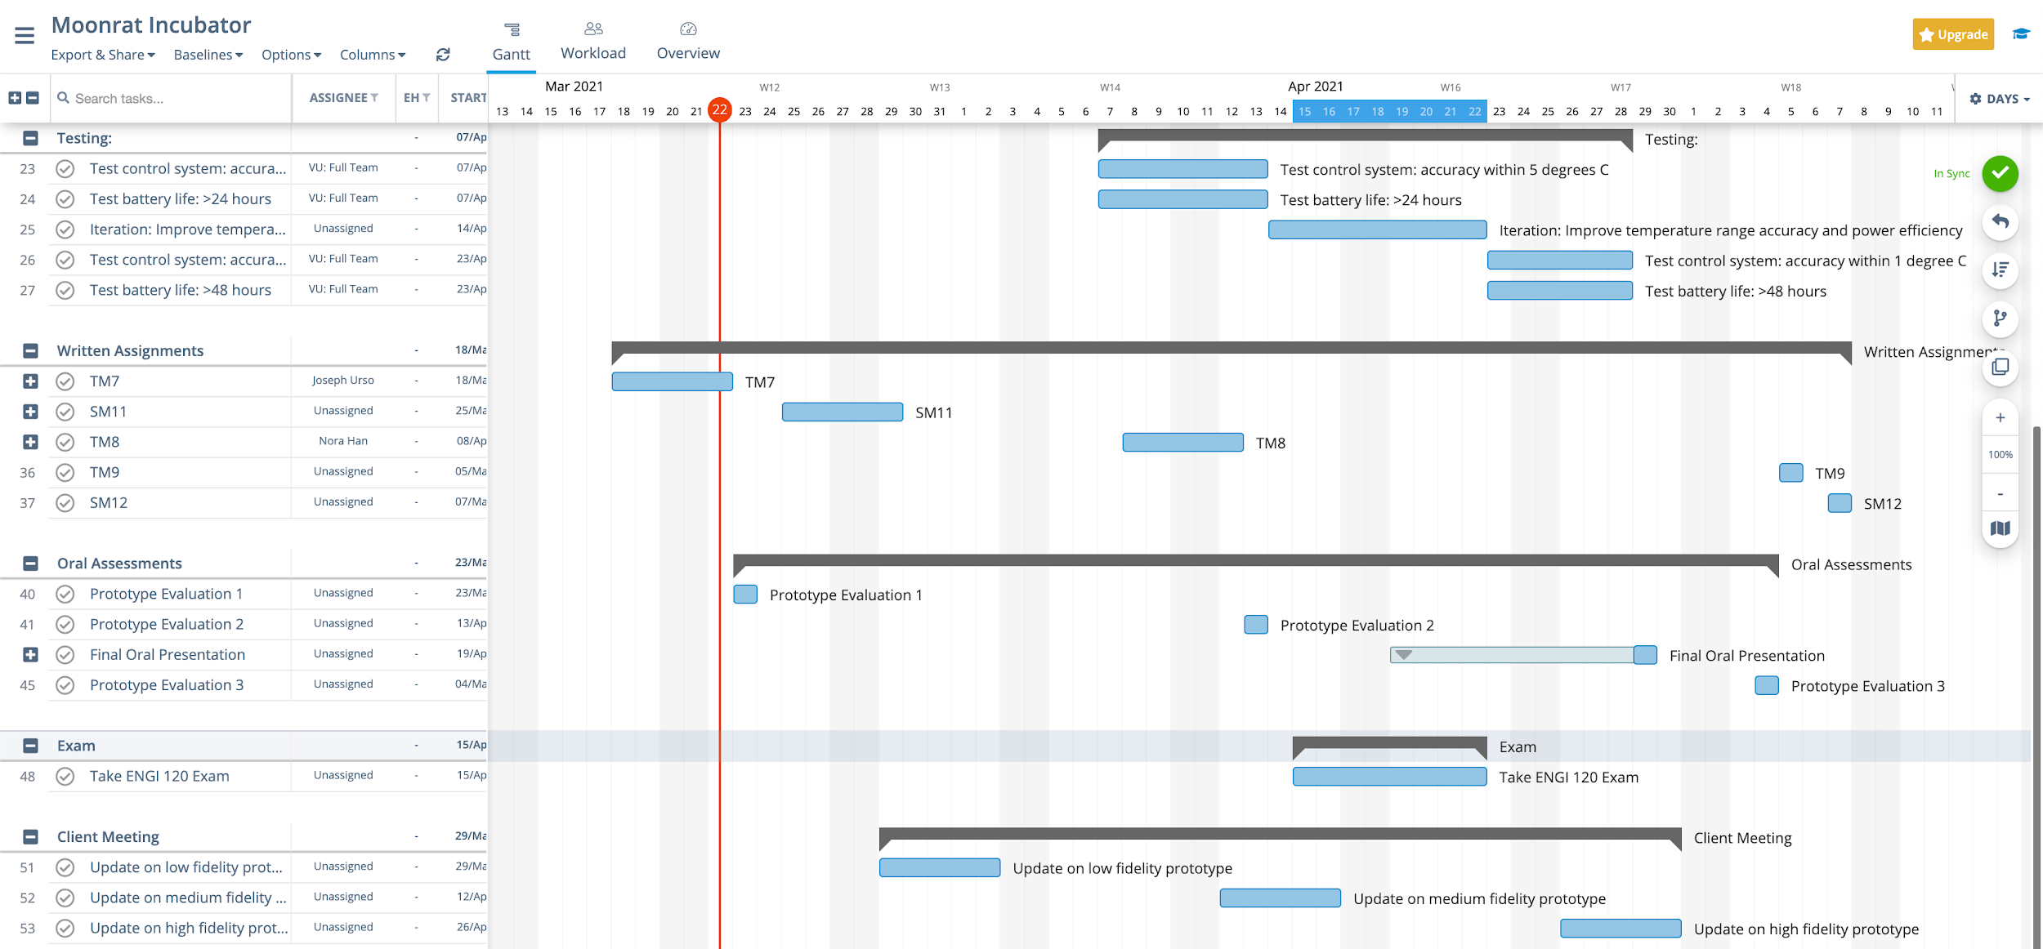

***Figure 3: Part 3 of Moonrats Gantt Chart***

A timeline of our project is the top portion of our Gantt Chart. Important deadlines and meetings are listed at the bottom of the Gantt Chart. Completed tasks are highlighted in green. Tasks that are late are highlighted in red. Milestones are indicated as orange diamonds. They are connected to the task that would have been considered a milestone. We were unable to add them directly to the tasks without paying for a subscription to Asana. Note: All official prototype evaluations are considered milestones.

**Conclusion**

1. Before we begin assembling our medium fidelity prototype, we need to get an estimate of the spatial organization of our device. We will accomplish this with our low fidelity prototype. This is important because we are working with a small system (a thermos) and will be implementing many components, such as a rechargeable 12 V battery, a control system, and a storage area specifically for the Petrifilms. In our medium fidelity prototype, we want to test if the battery can last 24+ hours within the thermos. We want to do this in our medium fidelity prototype to ensure that our design criteria is satisfied before continuing to a high fidelity prototype. Based on our results, we will be able to determine the battery or insulation method to use during our high fidelity prototype. Ideally, our ordering of tasks will allow us to test our design criteria so that we can produce a successful high fidelity prototype.
2. At each team meeting, we will review our Gantt chart. We will assess if all tasks prior to the meeting have been completed. If not, we will discuss why a task has not completed, and if there is any way that another team member could step in in order to speed up the completion. If all tasks are completed, we will assess our upcoming tasks for the week, and ensure everyone understands their responsibilities for the week. Finally, we will preview the next 2-3 weeks in order to get an idea for what deadlines are slowly approaching. If we fall behind, we may assign a team member or two to assist wherever help is needed.
3. The biggest unknowns in our schedule is the time it will take to order more materials. For instance, we are waiting to order a rechargeable battery for our high fidelity prototype until we can evaluate the battery used in the medium fidelity prototype. This could take substantial time late in our prototyping process, which would delay the construction of our high fidelity prototype. Another unknown is the implementation of the shelf that will hold the Petrifilms. As of now, we are unsure if we want to create this shelf out of metal, plastic, or directly from a 3D printer. In order to mitigate the lag from ordering materials, we will consider faster shipping. Additionally, we will build our shelf with plastic for our medium fidelity prototype. Once we evaluate it against our design criteria, we will either keep the plastic or choose to use another material.
4. A dependency in our process is that we will not be able to evaluate the battery or insulation method until the temperature control system is operational. The success of the control system depends on if our electronics and control system are functional and compatible with one another. If the battery or insulation method is ineffective, it is possible that we develop another medium fidelity prototype to test another battery or insulation method. A concurrency in our process will occur when we reach our high fidelity prototyping. We will need to connect all components of our control system to the Arduino and implement data logging for the control system. All electronic components must be integrated into one system.
5. During our first prototyping session in the OEDK, we realized that we did not plan our entire prototyping process. The next day, we had a team meeting and began outlining the remaining tasks of the semester. We prepared our task list before we knew that the focus for the class this week was to outline the remainder of the semester. This sped up the process of creating our Gantt chart.

1. Main Writers: Michael Tang and Joseph Urso